OVA Legislative Briefings
Here is an update on bills the OVA are tracking that have an impact on our work with crime victims.
The House Judiciary Committee met at 10:00 AM in Room 140 MC on 3/21/17.
- SB 261, Senator Scarnati’s bill extending statutes of limitations for child sexual abuse was passed over in committee.
- HB 594, Rep. Benninghoff’s bill prohibiting ARD for child sex offenses was unanimously reported out of committee.
- HB 631, Chairman Marsico’s bill which provides for a mandatory 3 year probation tail for sex offenses after offenders have served their sentences. The bill was reported out of committee with Dawkins and McClinton as negative votes.
The bill had unanimously passed the House in two previous sessions.
When questioned about the bill Chairman Marsico observed that an offender had committed another sex offense the day after he was released after serving his sentence.
- HB 741, Rep. Stephens’ bill passed out of committee with Briggs, Dean, McClinton and Miller voting in the negative.
The bill provides mandatory minimums for trafficking drugs to minors in drug free zones, offenses against the elderly, offenses against infants, for offenses committed while impersonating a law enforcement officer, violent crimes committed with firearms. Dean and McClinton remarked that there is no data to support the decrease in crime with the imposition of mandatory minimums. Chairman Petrarca remarked that this might be an issue that needs more study, although he did vote to pass the bill out of committee.
The maker of the bill noted that the mandatory minimums are analogous to the sentencing parameters already set by the legislature.

The House Favorably voted all four of the OVA Restitution Bills.
- HB 234 Representative Costa: Amends Title 42 (Judiciary and Judicial Procedure), in sentencing, further providing for collection of restitution, reparation, fees, costs, fines and penalties by adding that any county that does not engage the services of a private collection agency shall establish a collections enforcement unit. Additionally, statistical information shall be sufficiently detailed so as to show compliance with the requirements of the law. Final Passage March 20th, 192/4
- HB 236 Representative Corbin: Amends Title 42 (Judiciary and Judicial Procedure), in judgments and other liens, further providing for personal earnings exempt from process by adding that an order of attachment for support shall have first priority and an order for restitution shall have second priority; and, in sentencing, further providing for payment of court costs, restitution and fines by authorizing automatic periodic deductions from a bank account, subject to the agreement of the owner of the account. A court may, at sentencing, assign an amount not greater than 25 percent of the defendant's gross salary, wages or other earnings to be used for the payment of restitution, fines or court costs. Also provides if a defendant defaults in the payment of court costs, restitution or fine after imposition of sentence, the issuing authority or senior judge or senior magisterial judge may conduct a hearing to determine whether the defendant is financially able to pay. No employer may discharge, refuse to hire, or take any other adverse action against any person based in whole or in part on an order for the attachment of wages or the possibility thereof. Final Passage March 20, 179/18
- HB 280 Representative Delozier: Amends Title 42 (Judiciary), in bonds and recognizances, further providing for bail to be governed by general rules by establishing that any cash bail deposited by the defendant or a third party that is otherwise returnable to the defendant or party shall be held and applied to the payment of any restitution, fees, fines and costs imposed upon the defendant in connection with any criminal or delinquency case, unless the defendant or party shows that he or she would suffer an undue hardship. Final Passage March 20 146/51
- HB 285 Representative Stephens: Amends Title 42 (Judiciary and Judicial Procedure), in sentencing, further providing for collection of restitution, reparation, fees, costs, fines and penalties by stipulating that the Department of Corrections or the correctional facility to which the offender has been sentenced shall make monetary deductions of at least 25 percent of the offender's wages and 50 percent of all deposits made to inmate personal accounts for the purpose of collecting restitution, costs imposed, filing fees, and any other court-ordered obligation. Deductions shall be in addition to the full amount authorized to be collected pursuant to any order for support. Correctional facilities shall develop guidelines to that end and incorporate such guidelines into any contract entered into with a contract corrections facility. Final Passage March 20 144/51

The Senate Judiciary Committee met at 11:30 AM in Room 8E-B pm 3/21/17.
- SB 260, Senator Ward’s bill passed unanimously out of committee.
This bill would add crime victim representation to VSAC, as well as increase representation of child victim centered agencies to the VSAC at PCCD. The bill was passed out of committee unanimously.
- SB 522, more commonly known as the merger or consolidation bill, Chairman Greenleaf’s bill was passed out of committee, with negative votes by Senators Vulakovich, Langerholc, Rafferty and Sabatina.
This bill seeks to more accurately depict the powers and duties of agencies within what would now be the “Department of Criminal Justice.” The bill would also provide for a separate line item in the budget for the Office of Victim Advocate.
According to the Chairman, this bill is similar to the law in 40 other states. These states have not been negatively impacted in terms of public safety by implementation of this legislation.
- SB 523, Chairman Greenleaf’s bill was passed out of committee with a technical amendment sanctioned by OVA, with negative votes from Senators Langerholc, Rafferty, Sabatina and Vulakovich. In this bill, widely regarded as a companion bill to SB 522, would change the Pennsylvania Board of Probation and Parole to the Pennsylvania Parole Board and the Department of Corrections to the Department of Criminal Justice. SB 523 has the greatest impact on OVA, providing for confidentiality of records, powers and duties of the Office and designating the Office as a criminal justice agency.
Other Bills OVA is watching:

HB 274, Representative Marsico Amends the Protection from Abuse Act granting judges the ability to order the defendants to refrain from abusing the victim's pets.
HB 612 Representative Rozzi Amends Title 42 (Judiciary and Judicial Procedure), in limitation of time, further providing for civil action arising from childhood sexual abuse; and, in matters affecting government units, further providing for exceptions to sovereign immunity and governmental immunity. The bill states that in the case of an individual entitled to bring a civil action arising from childhood sexual abuse where the 12-year period has expired, the individual shall have an additional period of two years from the effective date of this clause to commence an action. Exceptions to sovereign immunity include acts of child sexual abuse in which the conduct constitutes an offense provided by the provisions of Title 18 (relating to crimes and offenses) enumerated in section 5551(7) (relating to no limitation applicable) if the injuries were caused by actions or omissions of the Commonwealth which constitute negligence. Exceptions to governmental immunity include acts of child sexual abuse in which the conduct constitutes an offense provided by the provisions of Title 18 (relating to crimes and offenses) enumerated in section 5551(7) (relating to no limitation applicable) if the claimant establishes that the local agency acted in a negligent manner and the action cause injury to the claimant.
HB 413 Representative Murt Amends Title 18 (Crimes and Offenses), in sexual offenses, establishing the offense of female mutilation
HB 441 Representative Murt Amends Title 42 (Judiciary and Judicial Procedure), in depositions and witnesses, further providing for victims of sexual or physical abuse prohibiting the disclosure of the actual initials of minor victims.
HB 489 Representative Quigley Amends Title 42 (Judiciary and Judicial Procedure), in sentencing, providing for sentencing for offenses involving indecent exposure when children present. The Pennsylvania Commission on Sentencing shall provide for a sentence enhancement within its guidelines for an offense under 18 Pa.C.S. 3127 (relating to indecent exposure), where the offense is graded as a misdemeanor of the first degree, specifying variations from the range of sentences applicable based on such aggravating circumstances as: (1) The number of persons present and under 16 years of age, (2) The age of each person present and under 16 years of age, and (3) The nature and character of the indecent exposure.
HB 517 Representative Bullock Amends the Crime Victims Act, in miscellaneous provisions, providing for disclosure and confidentiality of victims' records by adding that all records pertaining to a victim in the possession of or maintained by the Office of Victim Advocate are the property of the Office of Victim Advocate. The records shall be kept confidential and shall not be subject to the provisions of the Right-to-Know Law. Victim information and records relating to a victim contained in the database or maintained in relation thereto may be released by the Office of Victim Advocate to a State or local government agency that has a duty or need to maintain contact with the victim but shall not be disclosed to any other person without the written consent of the victim.
HB 574 Representative Davis Amends the Crime Victims Act, in administration, further providing for the Office of Victim Advocate and for powers and duties of victim advocate. In addition to current duties, the advocate shall also advocate for the interests of crime victims and represent those interests before other government officials. The advocate also may represent and advocate for the interests of crime victims generally, including the victims of juvenile crime.
SB 59 Senator Greenleaf Amends Title 61 (Prisons and Parole) establishing the Prison Industry Enhancement Authority; providing for employment of prisoners by private industry and for subcontracts with correctional agencies; establishing guidelines for prisoner compensation; and providing for location of private sector prison industry. The intent of the bill is to establish joint ventures between correctional facilities and private industry so that prisoners incarcerated in correctional facilities are productively engaged; private industry will become more competitive in the marketplace while not displacing job opportunities for civilian labor in the community. The authority shall: (1) Authorize the department to apply to the United States Department of Justice, Bureau of Justice Assistance or any successors for certification, as an umbrella authority, to assist other units of government seeking to participate in the program; (2) Act as an intermediary between the department, and its designees, and the United States Department of Justice, Bureau of Justice Assistance or any successors in complying with the mandatory criteria and program requirements for private sector prison industries; (3) Adopt procedures for determining whether a prospective private sector prison industry proposed by the department or any county correctional agency complies with the requirements of the program and other State law not inconsistent with this chapter; (4) Approve or disapprove proposals submitted to the authority from the department, or its designees, for private sector prison industry for inclusion or continuation in the program; (5) Monitor the department and its designees to ensure continuing compliance with this chapter and Federal law and provide proper notification of violations and proposed actions taken to ensure compliance; and (6) Designate which services to be performed or articles manufactured or assembled by prisoners are conforming to the program regulations and can be sold on the open market.
SB 189 Senator McGarrigle Amends the Crime Victims Act adding that victims of crime have the right to not be excluded from any criminal or juvenile proceeding in accordance with 42 Pa.C.S. 6336 (relating to conduct of hearings), unless the court, based on the record before it, determines that testimony by the victim would be materially altered if the victim heard other testimony at the proceeding.
SB 196 Senator Hughes Amends Title 23 (Domestic Relations), in protection from abuse, defining "electronic monitoring device" and further providing for relief by adding that an electronic monitoring device may be required to be placed on the defendant if the defendant is found to present a substantial risk of violating the final protection from abuse order or committing a crime against the victim punishable by imprisonment.
SB 312 Senator Boscola Amends Title 42 (Judiciary and Judicial Procedure), in sentencing, providing for sentencing for offenses involving violation of protection orders or consent agreements. The Pennsylvania Commission on Sentencing shall provide for a sentencing enhancement for certain offenses when, at the time of the commission of the offense, the defendant was in violation of a protection order or consent agreement issued by a court in favor of the victim against the defendant under Chapter 62A (relating to protection of victims of sexual violence or intimidation) or 23 Pa.C.S. Ch. 61 (relating to protection from abuse).
SB 313 Senator Boscola Amends Title 23 (Domestic Relations), in protection from abuse, further providing for relief and providing for shared telephone plans. A telecommunications service provider shall allow a person who is under a telephone plan contract with the provider and who is a victim of domestic violence involving another person under the same telephone plan contract to opt out of the contract without charge.
SB 314 Senator Boscola Amends Title 42 (Judiciary and Judicial Procedure) providing for registration of domestic violence predators; establishing the Domestic Violence Predator Assessment Board; and imposing powers and duties on the Pennsylvania State Police and on the Pennsylvania Board of Probation and Parole.
SB 449 Senator Bartolotta Amends Title 18 (Crimes and Offenses), in assault, further providing for probable cause arrests in domestic violence cases by adding that in determining whether to admit the defendant to bail, the issuing authority may use a risk assessment tool adopted. A court of common pleas may adopt a bail risk assessment tool to aid in evaluating the relative risk that a defendant will assault the defendant's alleged victim while on bail.

As always, it is good to reach out to your state legislators to let them know your position on certain bills. If there is an ACTION alert requested on a particular bill, we will try to get that out as soon as possible. Sometimes things happen quickly and that isn’t always an option.

Also don’t forget to join us at the capitol for National Victims’ Rights Week!

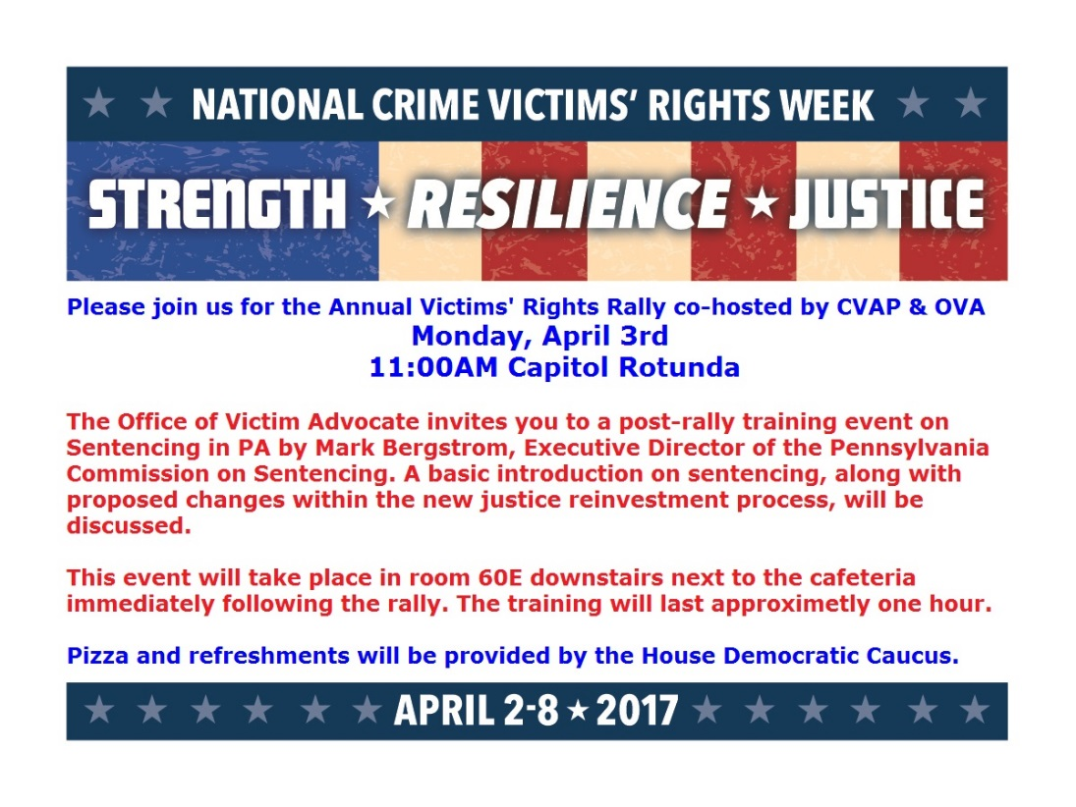
Thank you, Jennifer Storm, Victim Advocate

